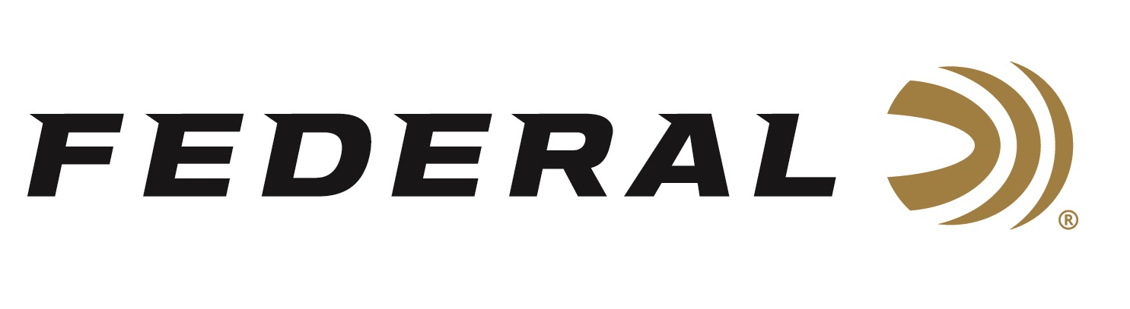

FOR IMMEDIATE RELEASE

Team Federal Earns Multiple NSSA All-American Designations

ANOKA, Minnesota – April 15, 2026 – Federal Ammunition congratulates Stuart Brown, Rocky Romo, Mark Vaillancourt, and Melissa Hinton on earning their way onto the 2026 NSSA All-American Teams. The teams were announced during the Triple J Classic held at the National Shooting Complex in San Antonio, TX. The premier event ran April 9-12, 2026, and drew more than 160 of the best skeet shooters in the nation.

Making the Open First Team was Stuart Brown and Rocky Romo. Mark Vaillancourt earned his spot on the Open Second Team and Melissa Hinton was named to the Lady First Team. For Stuart Brown, a 2021 NSSA Hall of Fame inductee, this marks his 29th All-American First and Second Team honors. Born and raised in Sugar Valley, Georgia, Brown currently serves in the United States Air Force as the 414th Maintenance Squadron F-15E Superintendent as a Chief Master Sergeant with 39 years of service.

At the Triple J Classic, Rocky Romo landed on the podium in the 28-ga event. His performance earned him a Runner-Up finish in the Open Division and a championship in the Collegiate Division. Romo, a Junior at Lindenwood University, also finished the four-gun event with Runner-Up finishes in the .410 Collegiate Division and the High Over All Collegiate Division.

Federal Ammunition products, including the new All-American, are available at dealers nationwide and online. All-American features a one-piece Podium wad and high-antimony lead shot that balances hardness and density. The loads are constructed with a straight-wall hull, an inserted plastic base wad, and a striated tube for optimum performance. All-American offers a much better option than standard target loads for competitors in trap and skeet. Learn more at: All-American.

Federal Ammunition products are available at dealers nationwide and online. For more information on all Federal products and to sign up to receive notifications about new product availability, rebate promotions, and other brand news via email, visit www.federalpremium.com.

Press Release Contact: JJ Reich
Senior Manager – Press Relations
E-mail: media@tkghunt.com

About Federal Ammunition
Federal, headquartered in Anoka, MN, is an ammunition brand of The Kinetic Group, owned by CSG, a globally diversified industrial group based in Prague, Czech Republic. Since 1922, Federal has been a leader in ammunition innovation, delivering high-quality sporting and hunting products to shooters worldwide. With a commitment to conservation and the outdoor community, Federal continues to manufacture industry-leading ammunition that enhances the shooting experience while supporting outdoor traditions.

